
Faculty of Engineering and Applied Science
ENGR 4940U Capstone Systems Design for ECSE I

Collaborative Requirements Elicitation and Prioritization for Smart City Services

Team Members
First name | Last name | Student Id
Hanum | Magaji | 100829979
Kanishk | Ghai | 100815261
Owais | AbdurRahman | 100879105

Faculty Advisor: Dr. Sanaa Alwidian
Capstone Coordinator (Fall 2025): Dr. Q. Mahmoud

Table of Contents
Table of Contents 2
1. Concept Generation and Analysis 4
1.1 Concept Generation Process 4
1.2 Structural and Relational Models 4
1.3 Sensitivity Analysis and Concept Ranking 5
Table 1.1: Sensitivity Analysis 5
1.4 Risks And Mitigations 5
Figure 1.1 — High‑level architecture. 6
2. Conceptual Design (30%) 6
2.1 Functional Decomposition 6
2.2 Data Model (Firestore Collections) 6
2.3 API Surface (sample) 7
2.4 Algorithms 7
Figure 2.1 — Sequence of submission, clustering, and prioritization. 7
3. Definition of Integration Tests 8
Table 3.1 - Component Interfaces 8
Figure 3.1 — Integration test workflow. 9
3.1 Example 9
4. Estimated Cost 11
4.1 Equipment and Software Costs 11
Table 4.1: Estimated Equipment and Software Costs 11
4.2 Total Estimated Project Cost 12
Table 4.2: Total Estimated Project Cost 12
5. Updated Project Plan 12
6. Contribution Matrix 13
7. References 14

List of Tables
Table 1.1: Sensitivity Analysis 4
Table 3.1 - Component Interfaces 7
Table 4.1: Estimated Equipment and Software Costs 11
Table 4.2: Total Estimated Project Cost 12

List of Figures
Figure 1.1 — High‑level architecture. 6
Figure 2.1 — Sequence of submission, clustering, and prioritization. 7
Figure 3.1 — Integration test workflow. 9

1. Concept Generation and Analysis
The concept generation stage for this project, on Requirements Elicitation and Prioritization of Smart City Services serves as a bridge between understanding the problems and developing the solutions. This stage allows for the definition of several potential solutions to efficiently gather, manage, prioritize and order requirements for smart city projects, in alignment with the wishes of the stakeholders and the safety and well-being of the general public.
By nature, the smart cities sector has a wide range of interested parties who may have conflicting interests. Parties to consider include government agencies, private companies, and the general public, as well as environmental impact on vegetation and wildlife. Due to the aforementioned complications, a system to track requirements for a smart cities project needs to be robust and scalable, with a high degree of accessibility and usability. The concepts generated all offer different ways to tackle the needs of the project, and include changes in system structure, technology used, and methods of implementation.

1.1 Concept Generation Process
In order to generate the best possible solutions to the problem, the team employed a number of techniques, including market analysis of existing products in different sectors, identification of real-world issues that may be prioritized in a smart cities project, and evaluation of potential solutions in line with the needs and wants of the interested parties.

Concept A - NLP Clustering Model
Concept A proposes a centralized web-based platform where all stakeholders, including citizens, city planners, and administrators, submit their requirements via a unified web interface.
The backend, hosted on a single cloud environment (Firebase + Python/FastAPI), performs all data processing, NLP clustering, and prioritization logic before storing the results in a central database. This model follows a Software-as-a-Service (SaaS) design pattern: lightweight clients interact with a centralized, intelligent backend through secure APIs.

Advantages and Disadvantages

a. Architectural Simplicity and Consistency
All computation, storage, and model management reside in a single cloud environment, which simplifies version control, testing, and continuous integration. The FastAPI backend handles input validation, NLP processing, and prioritization within the same runtime context, eliminating synchronization issues. Using Firebase Firestore as the unified database avoids replication conflicts and ensures that all stakeholders interact with the same, up-to-date dataset.

b. Performance and Efficiency
With no intermediate edge nodes or blockchain consensus layers, latency is minimal—typically under two seconds for clustering batches of 50–100 requirements.Central processing allows effective vector caching (e.g., pre-computed TF-IDF or SBERT embeddings) to accelerate subsequent analyses.
Load balancing can be achieved easily by scaling a single cloud API horizontally rather than coordinating multiple heterogeneous devices.

c. Cost-Effectiveness
The entire solution can run on free or low-tier cloud services: Firebase Hosting, Firestore, and Authentication often remain within the free quota. Computationally heavy NLP tasks (e.g., embedding generation) can use free Colab notebooks during development, then export processed models to the main backend. No specialized hardware, distributed frameworks, or external tokens (as required in blockchain systems) are needed.

d. Feasibility for Academic Timeline
The architecture supports a phased prototype, in which students can demonstrate functional milestones (submission, clustering, prioritization) incrementally without having to build infrastructure first. The design remains easily explainable in documentation and presentations, satisfying the clarity requirement for Capstone evaluation.

e. Ease of Testing and Evaluation
The entire workflow (requirement submission → clustering → prioritization → visualization) can be tested locally or in the cloud using mock stakeholders. Integration and acceptance tests are deterministic, reproducible, and easy to automate (using Firebase Emulator and Postman). Faculty and peers can evaluate the system live through the hosted interface without needing multiple setup environments.

Concept B: Mobile Application for Citizen-Centric Requirement Input
A centralized web platform that allows different stakeholders (city officials, planners, citizens, investors) to log in, submit requirements, and collaboratively prioritize them. This would be distributed over any mobile application platform to all residents of the city, to ensure robust, real-time data gathering from the general public.

Advantages and Disadvantages

a. High Accessibility and Increased Engagement
The distributed nature of this solution allows for real-time gathering of requirements from the residents of a city. This data can be processed and refined in order to determine what is most important in the eyes of a resident in terms of requirements of the new smart cities project.

b. Integration with Location Based Services
Taking advantage of the location services integrated in mobile devices allows for the gathering of more useful data. Certain requirements being more popular with certain demographics of people as well as residents of certain areas may help guide the prioritization process, allowing project managers to decide on who is more impacted and who has more sway on the project.

c. Potential Bias against Unprivileged Users
The nature of this application may prove to be biased in data collection, due to the fact that access to the application is needed and a general education of technology is required in order to use the application.

d. Resource and Cost Constraints
The requirements for the platform to always be running and to store vast quantities of data provide a significant cost, financially, and in terms of time and space as well. The infrastructure required to support this application would take time to build and a significant amount of money to maintain, and is outside the scope of the Capstone project.

Concept C – Fully Decentralized Blockchain Model:
This approach envisioned storing all requirement submissions and prioritization votes on a blockchain ledger to ensure transparency and immutability.

Advantages and Disadvantages

a. Over-engineering for the Problem Domain
The project’s pain point is requirement prioritization, not tamper-proof financial transactions. A full distributed ledger protocol adds heavy consensus mechanics (e.g., Proof-of-Work / Proof-of-Authority) that do not directly improve NLP clustering accuracy or stakeholder satisfaction. Smart-contract development (Solidity or Hyperledger Fabric) would shift focus away from the software-engineering objectives toward blockchain infrastructure design.

b. Performance and Latency Limitations
Block confirmation times, even on test networks, introduce multi-second to minute-level delays. For an interactive web platform where users expect near-instant feedback after submitting ideas, this latency is unacceptable. On-chain storage of text data is inefficient: requirements averaging a few hundred bytes each would quickly inflate block sizes and transaction costs.

c. Cost and Maintenance Overhead
Running or joining a blockchain network requires persistent nodes, wallets, gas tokens, and monitoring utilities. None of these fit within the zero-cost or free-tier constraints under which the capstone must operate. Any public-chain prototype would expose student data to external systems, conflicting with institutional privacy guidelines.

d. Integration Complexity
Integrating blockchain with NLP requires a hybrid data-flow layer (off-chain AI processing → on-chain commit), which multiplies interface points and test cases. Debugging deterministic smart-contract logic alongside non-deterministic ML inference adds conceptual mismatch: blockchain thrives on immutability, whereas ML models evolve.
After qualitative and quantitative evaluation, Concept A was selected as the most feasible for a student-level prototype due to its manageable scope, clear data flow, and scalable structure.

1.2 Structural and Relational Models
The chosen design consists of three main subsystems:
- Frontend (User Interface): Web dashboard where stakeholders submit requirements, view clusters, and rank priorities.
- Backend (AI and Data Layer): NLP clustering engine using Python libraries (Gensim, SpaCy) and Firebase for real-time database management.
- Prioritization Module: Implements MoSCoW and weighted scoring algorithms.

1.3 Sensitivity Analysis and Concept Ranking
Each concept was evaluated against criteria such as cost, complexity, scalability, and stakeholder transparency.

Table 1.2: Sensitivity Analysis

Criteria | Concept A (Centralized NLP) | Concept B (Hybrid Edge-Cloud) | Concept C (Blockchain)
Cost | Low | Medium | High
Complexity | Moderate | High | Very High
Scalability | High | High | Medium
Transparency | Medium | Medium | Very High
Suitability | Excellent | Moderate | Poor

Concept A achieved the highest overall suitability score (85%) and was thus selected as the primary direction.
(Figure 1.1: Concept Architecture Diagram — showing User Interface, NLP Engine, and Database Interaction)

1.4 Risks And Mitigations
- Data quality risk → adopt structured prompts and language validation
- Bias in clustering → include human‑in‑the‑loop review and re‑labeling.
- Privacy concerns → anonymize PII and enforce role‑based access control.
- Model drift → snapshot vectorizer parameters and keep evaluation sets.

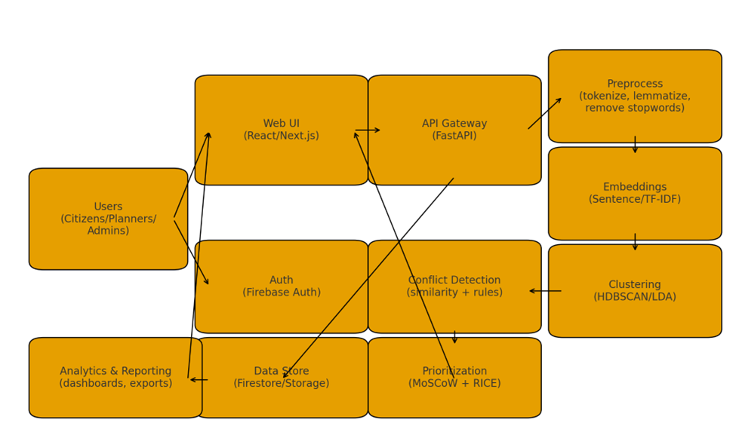

Figure 1.1 — High‑level architecture.

2. Conceptual Design

2.1 Functional Decomposition
The system was decomposed into six core functional modules:
- User Management System: Authentication, authorization, and user role control.
- Requirement Submission Interface: Collects and validates stakeholder input.
- NLP Clustering Engine: Groups similar requirements using cosine similarity and topic modeling (LDA).
- Conflict Detection Module: Identifies contradictory requirements through semantic comparison.
- Prioritization Dashboard: Implements MoSCoW and weighted scoring models.
- Visualization and Reporting Module: Displays results and exports summaries.

2.2 Data Model (Firestore Collections)
• users {uid, role, org}
• requirements {id, uid, text, timestamp, language, status}
• embeddings {req_id, vector_hash, model_ver}
• clusters {cluster_id, member_ids[], centroid, labels}
• conflicts {pair_ids[], score, rationale}
• priorities {req_id, moscow, rice_score}

2.3 API Surface (sample)
POST /requirements — submit text
GET /clusters — list clusters
POST /prioritize — apply MoSCoW/RICE
GET /reports/summary — export CSV/PDF

2.4 Algorithms
Pre‑processing: lowercase, punctuation removal, tokenizer, lemmatizer, stopword list.
Embeddings: baseline TF-IDF; stretch goal: sentence embeddings.
Clustering: HDBSCAN for density‑based grouping; LDA for topic labels.
Conflict detection: pairwise similarity + antonym/rule checks.
Prioritization: RICE = (Reach × Impact × Confidence) / Effort; MoSCoW categories via stakeholder votes.

Figure 2.1 — Sequence of submission, clustering, and prioritization.

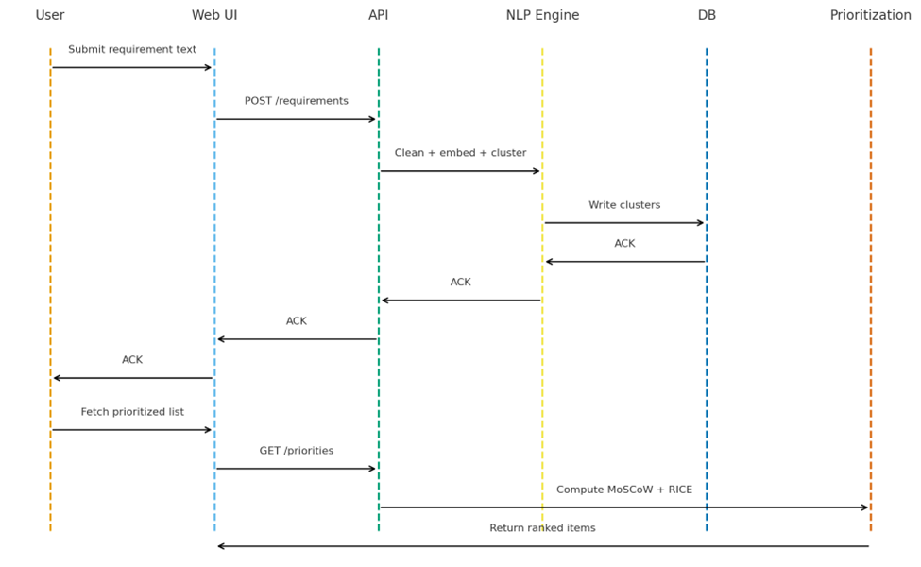

3. Definition of Integration Tests
The following table details the connections between the components identified in the system architecture (Figure 1.1), specifying the data, frequency, and constraints for each interaction.

Table 3.1 - Component Interfaces
Connection | Information Transferred | Frequency | Constraints
Web UI -> API Gateway | POST /requirements with requirement text. GET /priorities request. | On-demand (User action) | Requires Firebase Auth token.
API Gateway -> NLP Engine | Requirement text for processing ("Clean + embed + cluster"). | On-demand (Triggered by POST /requirements) | Internal service call.
NLP Engine -> DB (Firestore) | Processed clusters, embeddings, and conflict data ("Write clusters"). | Asynchronous (After processing) | Write access to Firestore collections.
DB (Firestore) -> API Gateway | Database write acknowledgment ("ACK". | Real-time (On write success) | N/A
API Gateway -> Web UI | Submission acknowledgment ("ACK"). Prioritized list ("Return ranked items"). | Asynchronous / On-demand | Must be a valid JSON response.
API Gateway -> Prioritization | Request to "Compute MoSCoW + RICE". | On-demand (Triggered by GET /priorities) | Internal service call.
Prioritization -> API Gateway | "Return ranked items" (a scored and sorted list). | On-demand (Response to compute request) | N/A
DB (Firestore) -> Analytics | Read access to all collections for dashboard and export generation. | On-demand (User requests report) | Read-only access for this service.

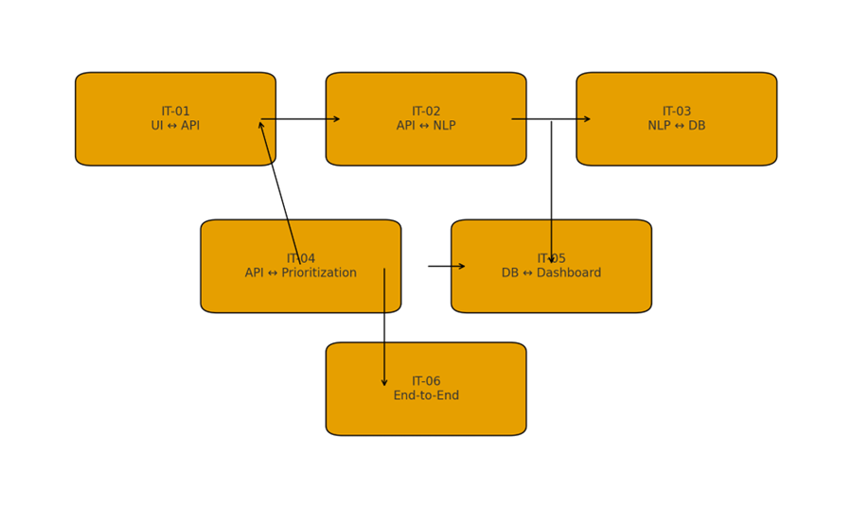

Figure 3.1 — Integration test workflow.

3.1 Example
Scenario: Testing the “Submit Requirement” workflow
Purpose:
Ensure that when a user submits a requirement through the web interface, the backend receives it, stores it in Firestore, and returns a success message.
Frontend Component:
The React web app collects a user’s text input — e.g.,
“We need real-time bus tracking in downtown”
and sends a POST request to the backend API endpoint:
POST /requirements
{
"text": "We need real-time bus tracking downtown.",
"lang": "en"
}
Backend (FastAPI):
The backend receives the request, validates the JSON, and calls the NLP preprocessing module.
NLP Module:
The text is tokenized, cleaned, and embedded (TF-IDF or SBERT vector).
The processed data is passed to the Database layer.
Database (Firestore):
A new document is created in the “requirements” collection:
{
"id": "r001",
"text": "We need real-time bus tracking in downtown.",
"embedding": [0.12, 0.35, 0.78, ...],
"timestamp": "2025-11-10T16:00Z"
}
Response Returned:
The backend responds with:
{ "status": "success", "id": "r001" }
Frontend Confirmation:
The UI displays “Requirement submitted successfully” and updates the local list.

4. Estimated Cost
This section provides a cost estimate based on the project's status as a university capstone with a 3-person team and a maximum budget of $800. The entire budget is allocated to direct equipment, software, and cloud service expenses.

4.1 Equipment and Software Costs
Costs are estimated for the full 8-month (2-semester) project duration.

Table 4.1: Estimated Equipment and Software Costs
Item | Description | Justification | Estimated Cost
Database & Auth | Firebase (Firestore/Auth) | The "Spark Plan" (free tier) is sufficient for prototype-level data storage, authentication, and user data. | $0.00
Code Repository & Software | GitHub, VS Code, Python, React/Next.js | All primary development tools, frameworks, and version control are open-source or provide free tiers for students. | $0.00
Cloud Hosting (API/NLP) | Cloud VM (e.g., DigitalOcean, AWS, Azure) | Required to host the FastAPI API Gateway and run the Python-based NLP Engine (for clustering, embeddings, etc.). | $320.00 (Est. $40/month x 8 months)
Contingency Fund | Budget reserve | Reserved for unforeseen costs, such as paid APIs, a more powerful server for the final demonstration, or domain name registration. | $480.00
Total Equipment/Software Cost |  |  | $800.00

4.2 Total Estimated Project Cost
The total project cost is allocated entirely to direct equipment and service expenses, staying within the specified budget.

Table 4.2: Total Estimated Project Cost
Cost Category | Estimated Cost
Total Equipment and Software Cost | $800.00
Total Estimated Project Cost | $800.00

5. Updated Project Plan
The original project plan, as detailed in Section 7 of Report #1, remains accurate and is on schedule. There are no changes to the timeline or scope at this stage.
The submission of this report (Report #2) marks the successful completion of Phase 2: System Design (Weeks 4-7).
We adopt six sprints (~2–3 weeks). Each sprint ends with a review and retrospective, and enforces an entry/exit gate.

Table 5.1: Updated Project Plan
Sprint | Goals & Exit Criteria
S1(Wk 14-16) | Repo+CI, preprocessing baseline, TF–IDF vectors; pass UT-01/UT-02
S2 (Wk 16–18) | Agglomerative clustering + API contracts; pass IT-01/IT-03
S3 (Wk 18–20) | UI dashboard MVP; MoSCoW entry; pass ST-01
S4 (Wk 20–22) | RICE scoring; conflict detection rules; load test LT-01
S5 (Wk 22–24) | HDBSCAN comparison; accessibility and security checks
S6 (Wk 24–26) | Docs, demo, final hardening and presentation

The project is now progressing into Phase 3: Implementation (Weeks 8-20). The immediate next steps, as per the original plan, are:
- Development environment setup and repository configuration.
- Backend API development (user management, requirement submission).
- Database implementation and ORM configuration.

6. Contribution Matrix

Name | Contribution
Hanum Magaji | 33.33%
Owais AbdurRahman | 33.33%
Kanishk Ghai | 33.33%

7. References
[1] ProductPlan, "What is MoSCoW Prioritization?" ProductPlan, 2025.
[2] DeepLearning.AI, "Natural Language Processing (NLP) [A complete guide]," 2023.
[3] Firebase, "Firebase Documentation," 2025.
[4] Gensim Documentation, "Topic Modeling and Similarity Analysis," 2024.
[5] IEEE, "Smart City Data Integration Frameworks," IEEE Access, 2024.

